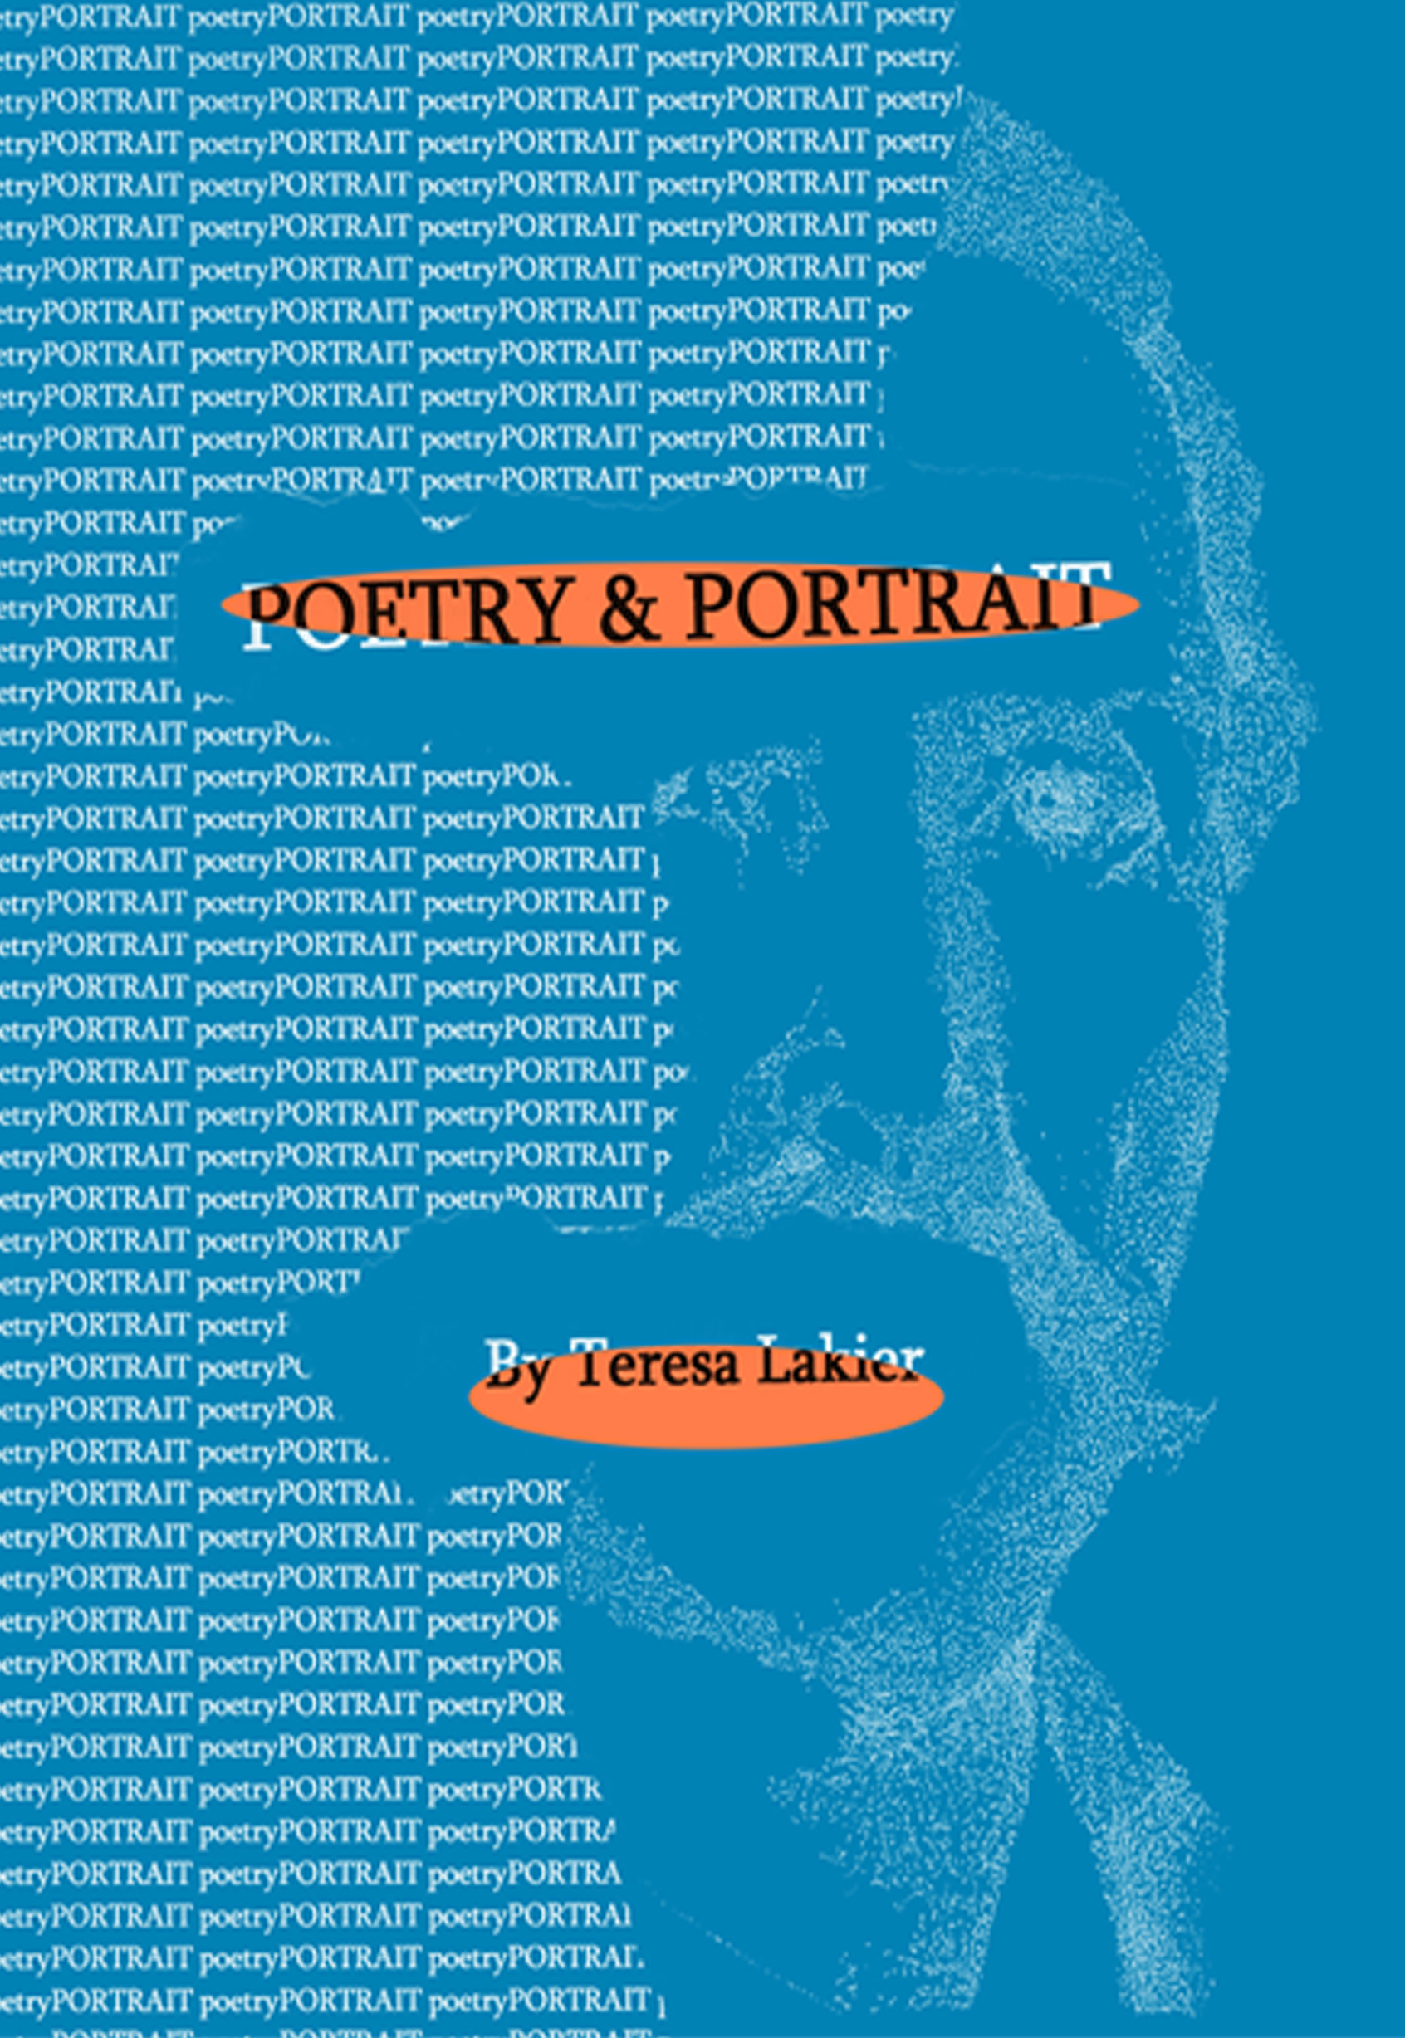
List Information, Summary, Demographics:

POETRY & PORTRAIT: AN ANTHOLOGY: PART I AND PART II

[Paperback]
Teresa Lakier (Author, Illustrator)

Poetry & Portrait is a poetical discourse of human character and self-evolution. It is also a visual and verbal portrait of men and women whom she has found on her journey and who have made an impression on her. Hopefully their thoughts will serve you well on your journey.

Summary

Teresa's purpose is to pay tribute to those heroic individuals who have contributed to the world. She hopes to honor them as a testimonial of their contribution. Through creative means, she finds them in my heart and hope others may do the same. We must all contribute, either as artist, or observer by: experiencing the soul through understanding our purpose, expanding our knowledge of our gifts, and by being aware of the historical stepping-stones of humanity throughout the ages. Without these contributions, which we must continually remind ourselves of, the past, present, and future would be lost in the thoughts of the here and now.

- Paperback: 154 pages
- Publisher: CreateSpace (November 8, 2011)
- Language: English
- ISBN-10: 1438210876
- ISBN-13: 978-1438210872
- Product Dimensions: 8 x 5.2 x 0.4 inches
- Target Audience: Young adult, Adult

