POETRY AND PORTRAIT: AN ANTHOLOGY: PART I AND PART II HITS AMAZON.

Author Teresa Lakier releases an Anthology of Poetry
Says the book deals with human character and self-evolution.

FOR IMMEDIATE RELEASE 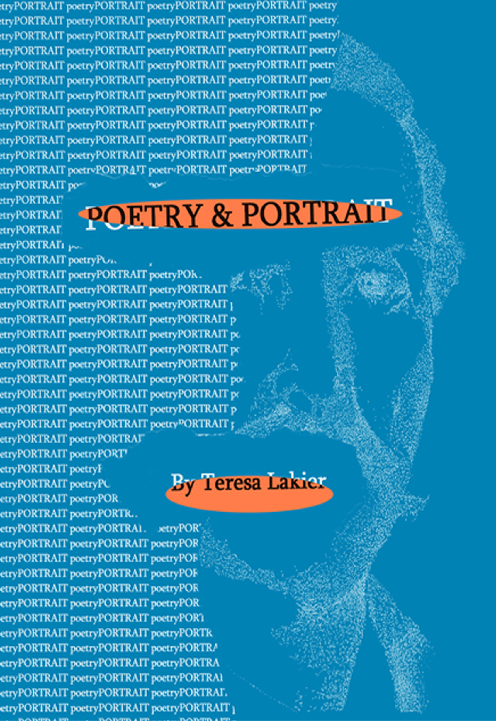

For Further Information Contact:
Teresa Lakier
310-801-2295
info@teresalakier.com
http://www.poetryandportrait.com
Los Angeles, CALIFORNIA, --- February 1, 2012---

Teresa Lakier has just recently self-published Poetry & Portrait: An Anthology: Part I and Part II. This poetical discourse includes illustrations to compliment the poetry. The book is a portrayal of the men and women whom she has found on her journey that have made an impression on her.

The author’s purpose is to pay tribute to those heroic individuals who have contributed to the world. It is her hope to honor them as a testimonial of their contribution. Through creative means, she finds them in her heart and hopes others may do the same. We must all contribute, either as artist, or observer by: experiencing the soul through understanding our purpose, expanding our knowledge of our gifts, and by being aware of the historical stepping-stones of humanity throughout the ages. Without these contributions, which we must continually remind ourselves of, the past, present or future would be lost in the thoughts of the here and now.

William S. Burroughs said, “Nothing exists until or unless it is observed. An artist is making something exist by observing it. And his hope for other people is that they will also make it exist by observing it. I call it creative observation, or 'Creative viewing.' ” This is what the author intends to achieve.

“Individuality of expression is the beginning and the end of all art,” said Johann Wolfgang von Goethe.
Likewise, the author uses her unique expression to write her poetical discourses individual to her alone.

